**Case study: Order Processing System**

Consider the following problem description: A mail-order company wants to automate its order processing. The initial version of the order processing system should be accessible to customers via the web. Customers can also call the company by phone and interact with the system via a customer representative. It is highly likely that the company will enhance this system in upcoming years with new features. The system allows customers to place orders, check the status of their orders, cancel an existing order and request a catalog. Customers may also return a product but this is only possible through the phone, not available on the web. When placing an order, the customer identifies himself by means of customer number (only for existing registered customers) or by means of his name and address. He then selects a number of products by giving the product number or by selecting products from the online catalogue. For each product, information such as price, a description and a picture (only on demand as they are usually high-resolution images of large size) are presented to the customer. Also, the availability of the product is obtained from the inventory. The customer indicates whether he wants to buy the product and in what quantity. When all desired products have been selected, the customer provides a shipping address and a credit card number and a billing address (if different from the shipping address). Then an overview of the ordered products and the total cost are presented. If the customer approves, the order is submitted. Credit card number, billing address and a specification of the cost of the order are used on the invoice, which is forwarded to the accounting system (an existing software module). Orders are forwarded to the shipping company, where they are filled and shipped. Customers who spent over a certain amount within the past year are promoted to be gold customers. Gold customers have additional rights such as being able to return products in an extended time period as well as earning more bonus points with each purchase. In addition, in cases where a product is on back order, gold customers have the option to sign up for an email notification for when the particular product becomes available.

(1). Identify actors and use cases for the system described above and show them on a UML Use Case Diagram.

ChatGPT建议的初始方案：

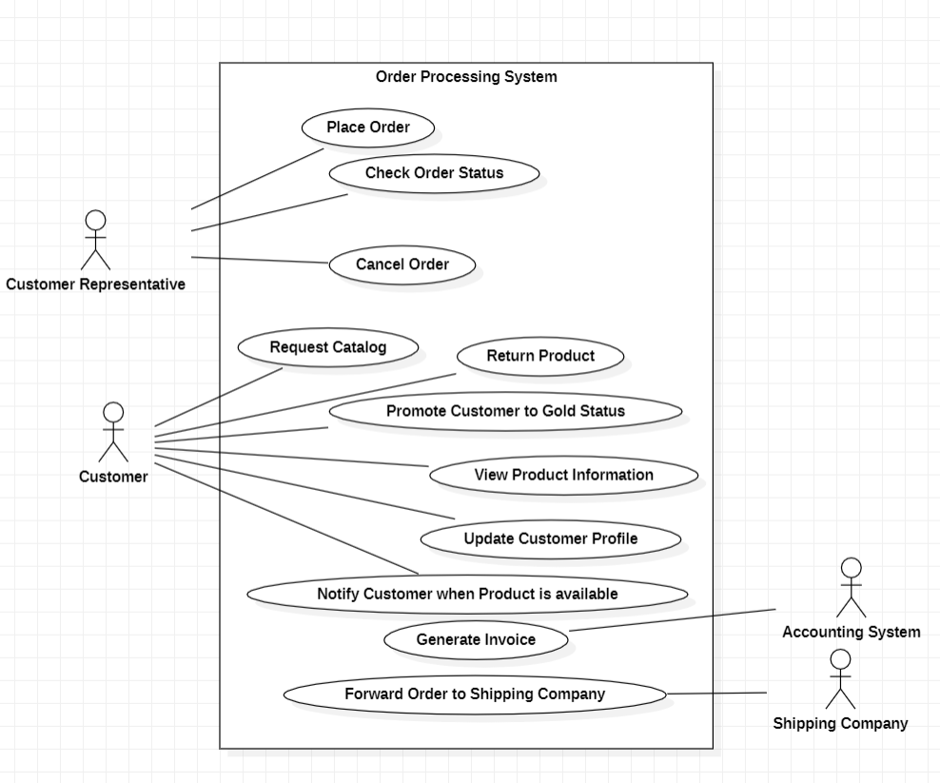

改进后的方案：

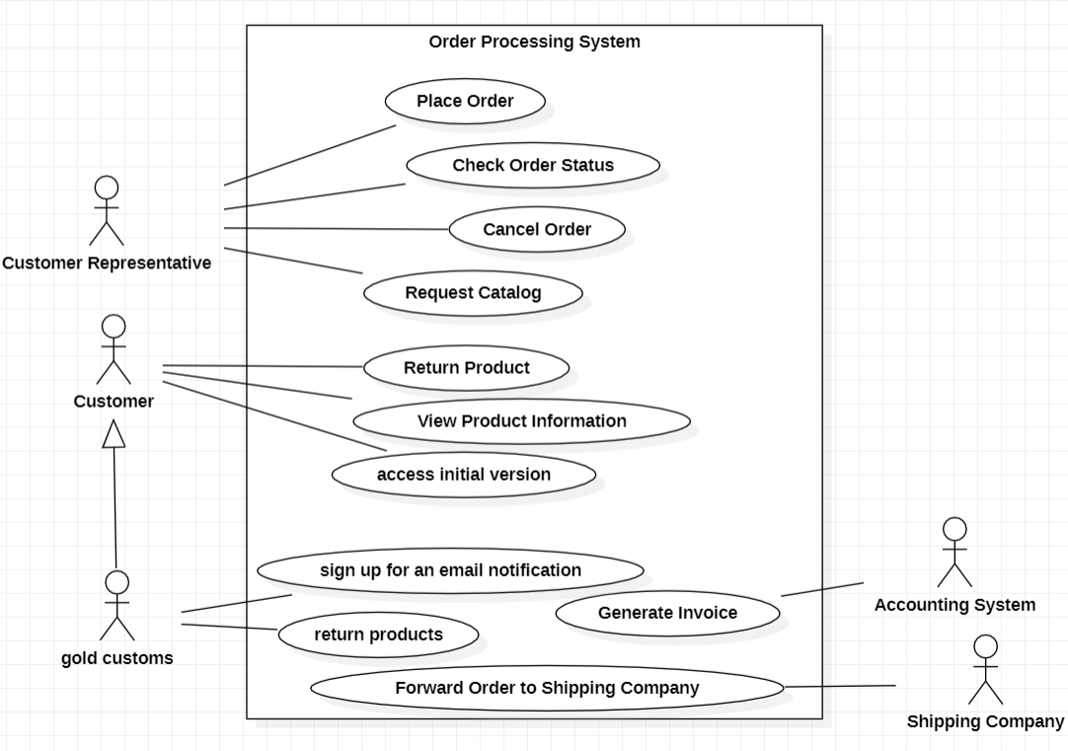

方案区别：

1. 增加了gold customer类，继承于Customer。与return products和sign up for an email notification两个用例关联。
2. 将Request Catalog用例与Customer Representative关联而不是customer。
3. Customer类增加了access initial version用例。
4. 删除Promote customer to gold status，Update customer profile和Notify customer when product is available用例。

AI辅助的过程记录：

我对描述：

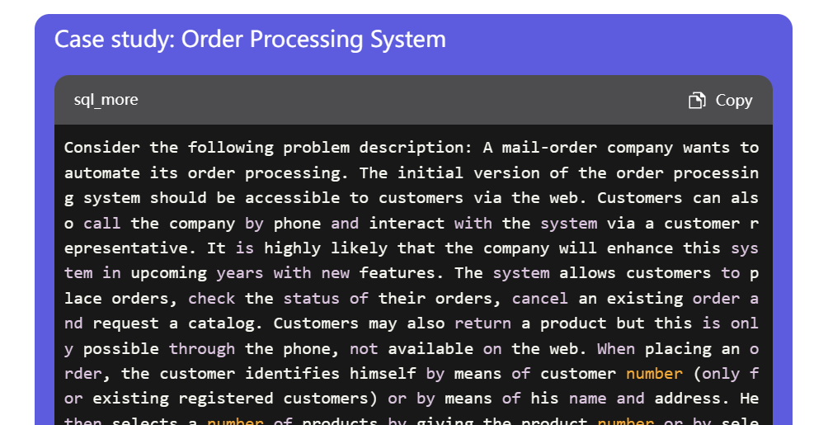

我对提问：

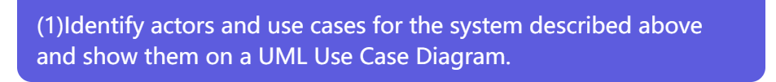

GPT的回答：

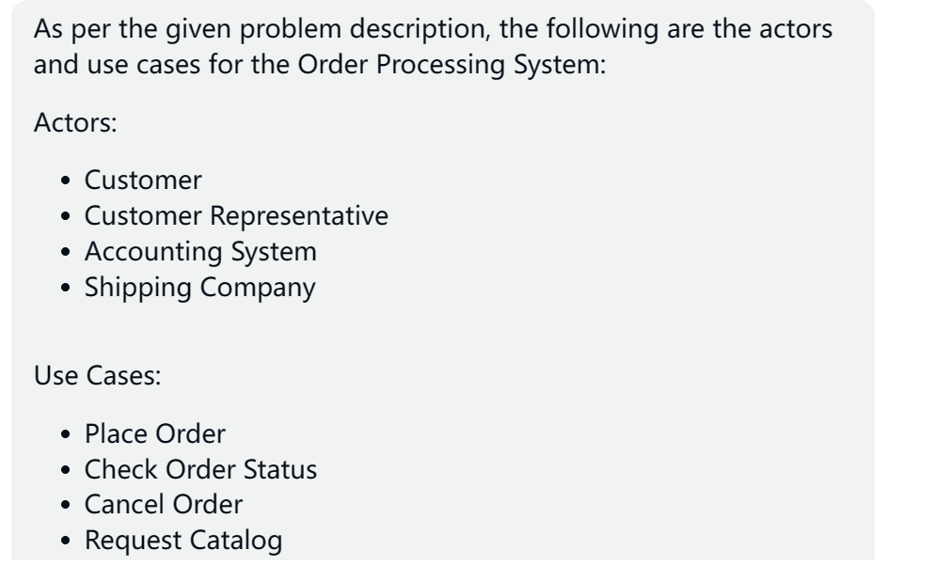

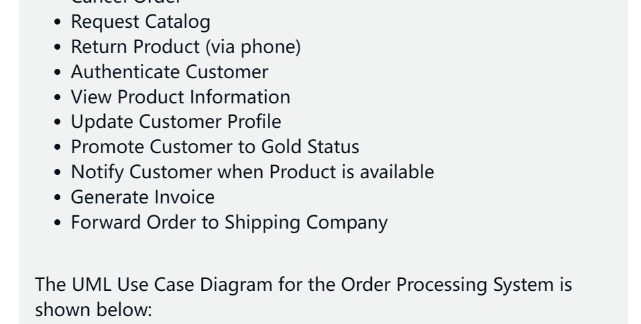

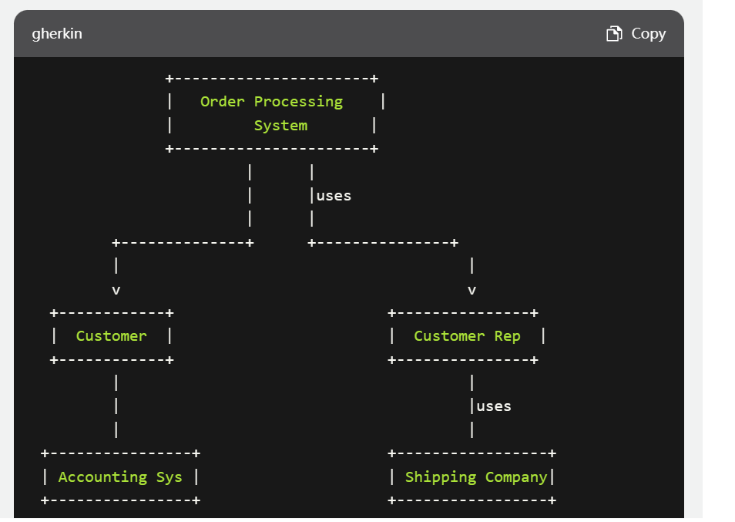

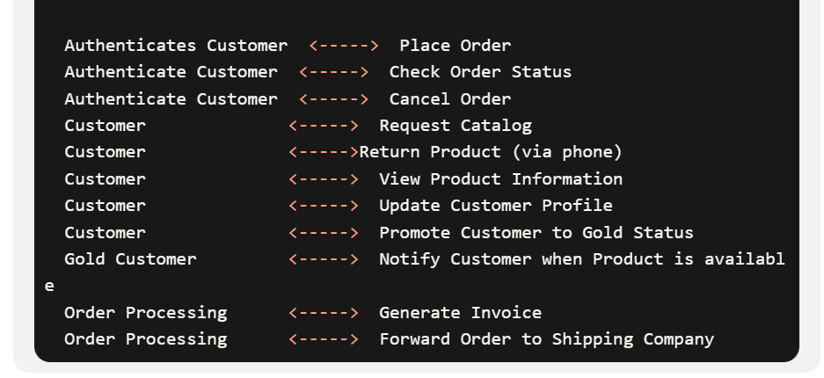

询问次数：1次

回答时间：数秒

(2) Perform a quick application domain analysis to come up with an object model for the above system. Express your findings with a UML Class Diagram, making sure to identify any critical operations of classes.

ChatGPT建议的初始方案：

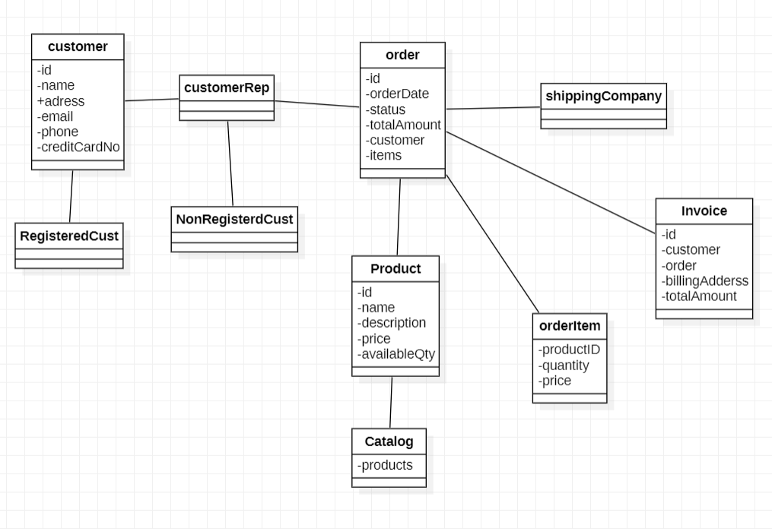

修改后的方案：

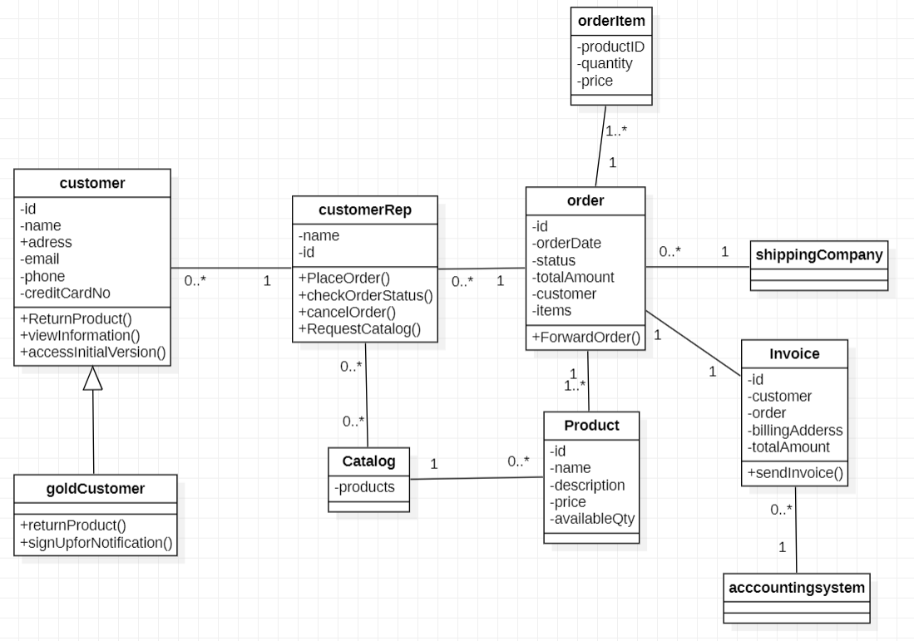

方案区别：

1. 删去RegisteredCust和NonRegisterdCust类。
2. 增加了许多方法，初始方案中并不包含方法。
3. 增加了多重度。
4. 增加了accountingsystem类。
5. 增加catalog类和customerRep类之间的联系。
6. 增加goldCustomer类作为customer类的子类。

我的提问：



GPT的回答：

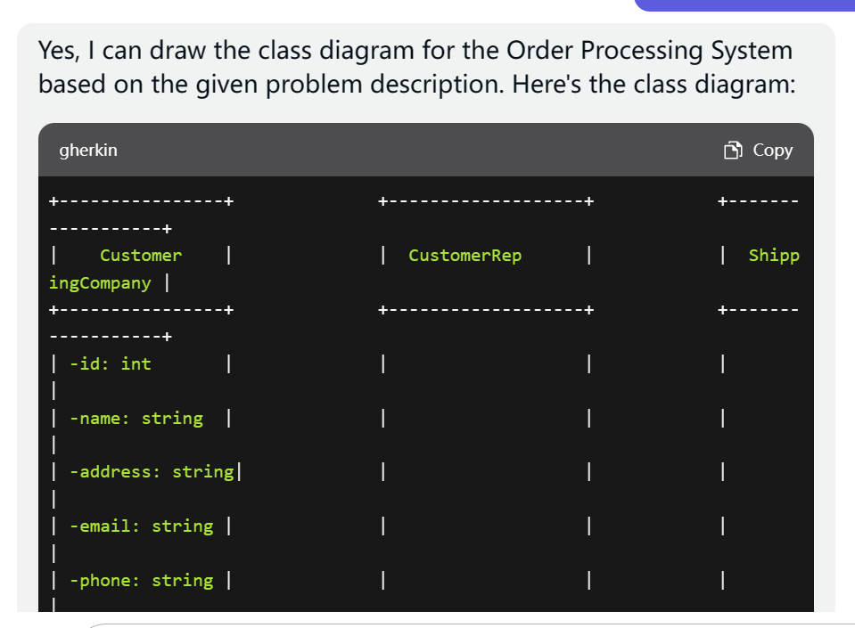

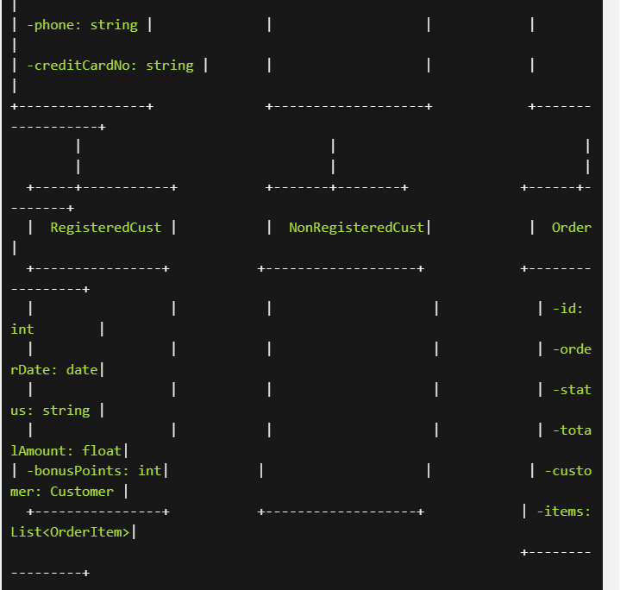

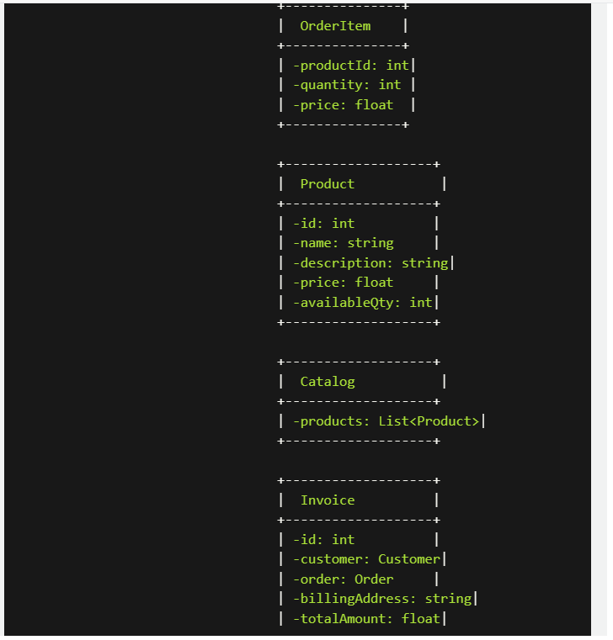

询问次数：1次

回答时间：数秒

Consider the following use case scenario (for use case “place order”):

*Ali is an existing customer of the order processing company described earlier, registered with their web site. Also assume that having browsed the printed catalogue he has, he already identified the two items (including their prices) he likes to buy from the company’s website using their product numbers (i.e. #2 and #9). First, he tries to buy one of product #2, but it is listed as unavailable in the inventory. Then, he adds two quantities of product #9, which turns out to be available, to his basket. He is then asked to confirm his registered shipping and billing addresses and credit card information from the customer database. He completes the order by clicking the Submit button. You may ignore processing of customer authentication.*

(3

) draw a UML Sequence Diagram for this particular scenario. You may use any software/solution domain objects if needed as well.

ChatGPT建议的初始方案：

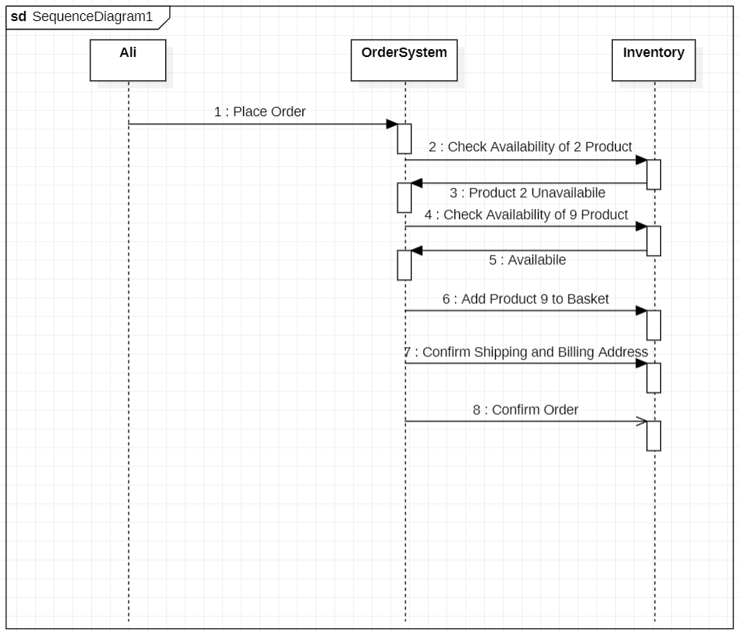

修改后的方案：

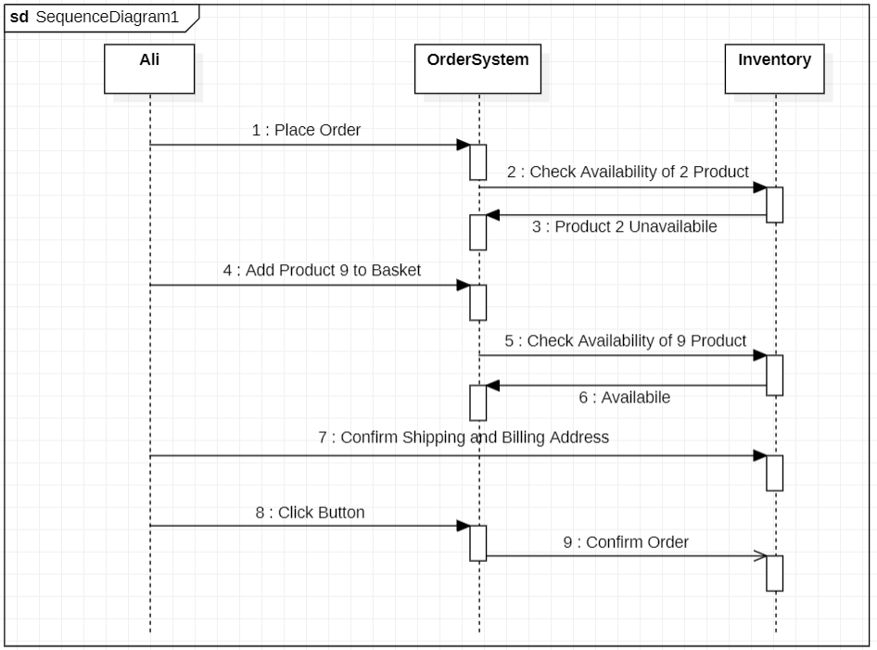

方案区别：

1. 将加入9到购物车的步骤与验证事物9的步骤顺序交换。
2. 加入购物车步骤变为Ali和OrderSystem之间。
3. 确认信息变为在Ali和Inventory之间。
4. 增加点击按钮步骤。

我的提问：

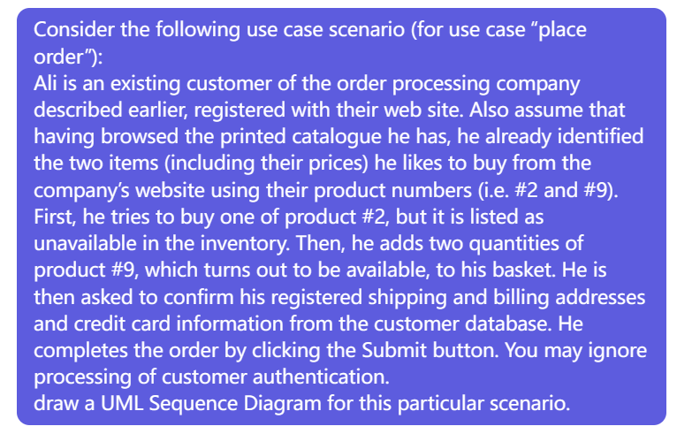

GPT的回答：

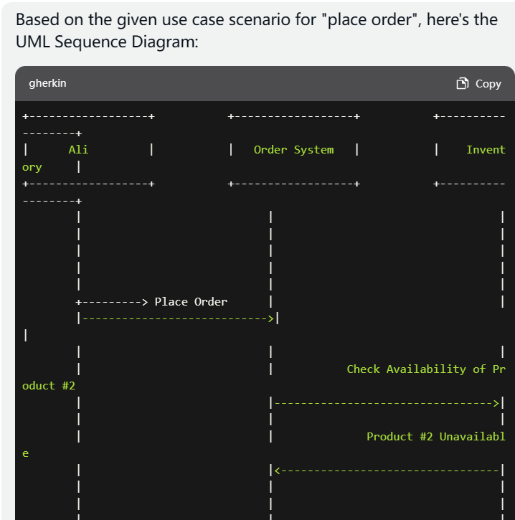

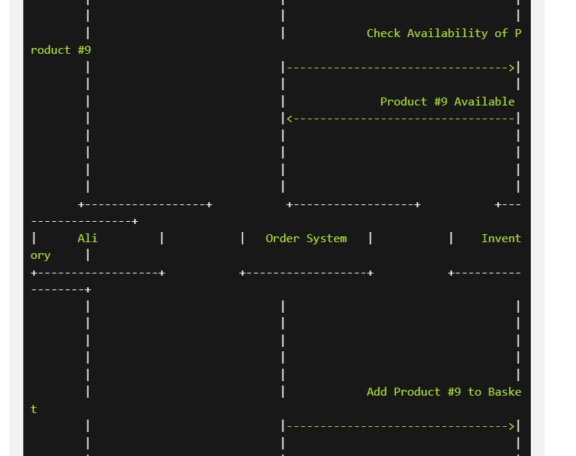

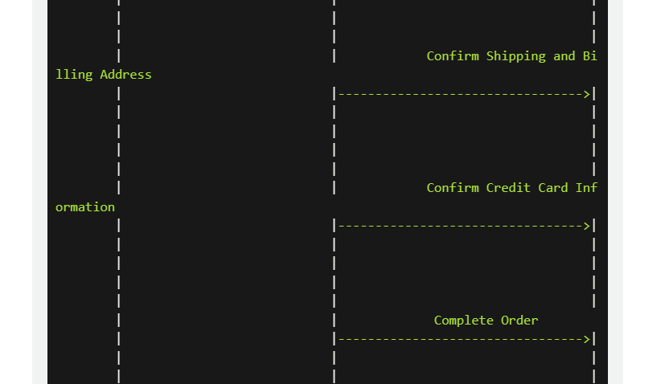

询问次数：1次

回答时间：数秒